Incomplete Dominance
Definition:
Incomplete dominance is a form of intermediate inheritance in which one allele for a specific trait is not completely expressed over its paired allele. This results in a __________ phenotype in which the expressed physical trait is a _____________ of the phenotypes of both alleles. Unlike in complete dominance inheritance, one allele does not dominate or mask the other allele. Incomplete dominance occurs in the polygenic inheritance of traits such as eye colour and skin colour.

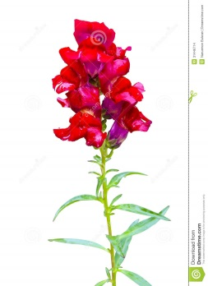
INCOMPLETE DOMINANCE IN SNAPDRAGONS
Example:
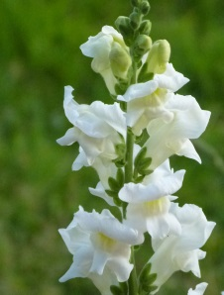
Incomplete dominance is seen in cross-pollination experiments between red and white snapdragon plants. In this monohybrid cross, the allele that produces the red colour (R) is _____ completely expressed over the allele that produces the white colour (r). The resulting offspring are all pink. The genotypes are: Red (RR) X White (rr) = Pink (Rr).
Use a Punnett square to demonstrate that all the offspring from this cross would be pink.

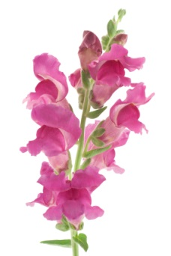

Use aPunnett square to show what would happen if plants from the first filial generation were allowed to cross:

Write out the ratio of genotypes:
Write out the ratio of phenotypes:
Show what would happen if the firs filial generation is allowed to cross pollinate with true breeding red plants:

Show what would happen if the first filial generation is allowed to cross pollinated with true breeding white plants:

In incomplete dominance, the intermediate trait is the _________zygous genotype. In the case of snapdragon plants, the pink plants are heterozygous with the (Rr) genotype. The red and white plants are both ________zygous for plant colour with genotypes of (RR) red and (rr) white.

POLYGENIC TRAITS
Polygenic traits are determined by more than one gene and by interactions among several alleles. The genes contributing to these traits equally influence the phenotype and the alleles for these genes are found on different chromosomes. The alleles have an additive effect on the phenotype resulting in varying degrees of phenotypic expression. Individuals may express varying degrees of a dominant phenotype, recessive phenotype, or intermediate phenotype. Those that inherit more dominant alleles will have a greater expression of the dominant phenotype, while those that inherit more recessive alleles will have a greater expression of the recessive phenotype. Those that inherit various combinations of dominant and recessive alleles will express the intermediate phenotype to varying degrees. Height, weight, eye colour, and skin colour are examples of polygenic traits.

